Local Union 136 Family Picnic
Saturday, August 22, 2015
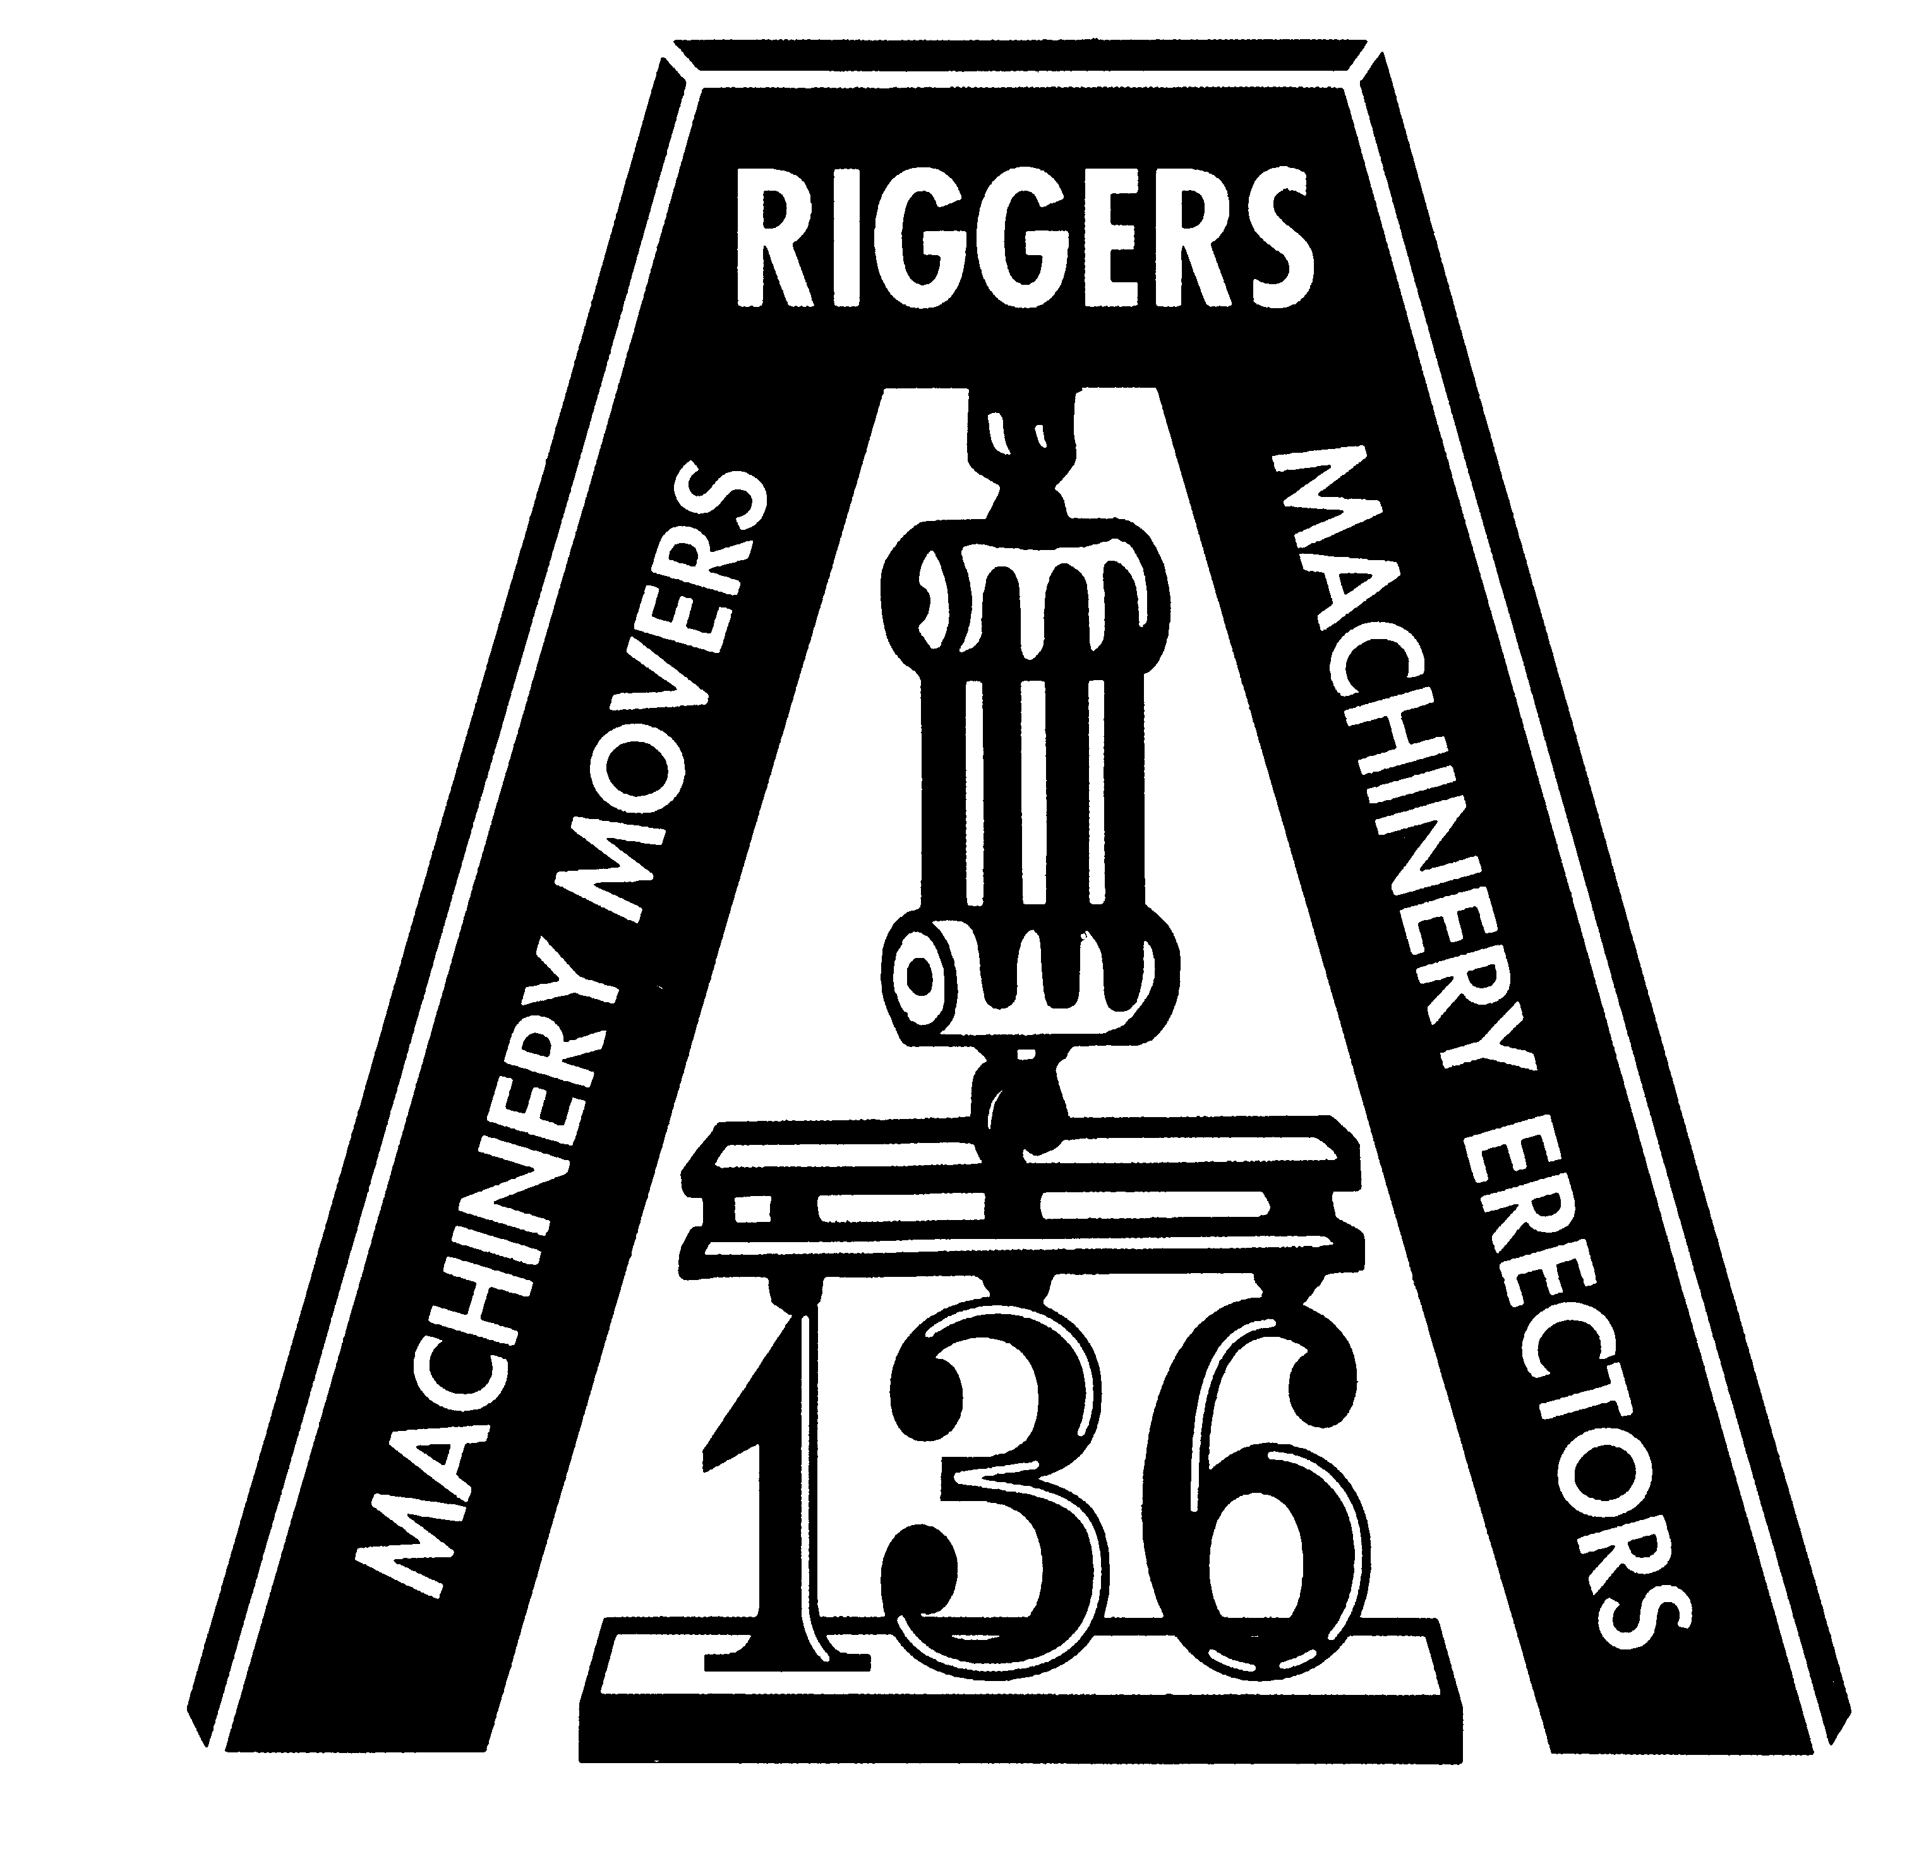

You and your family are invited to attend our 2015 Riggers Family Picnic. There will be activities for everyone!

- Food – cooked on site
- Beverages
- Entertainment by Mary Macaroni for kids (12 Noon – 3:00 pm)
- Moon Jumps for the kids (all day)
- Pony Rides (1:00 – 4:00 pm)
- Photo Booth (12 Noon – 4:00 pm)
- Live Music! Provided by The Lisa Rene’ Band (5:00 – 8:00 pm)
- Tents For shade or in the event of rain

Members are encouraged to send in their R.S.V.P. on time. We need to know how many adults and children will be attending; we don’t want to fall short on food and gifts.

Please join us!
Fraternally,

Robert Fulton, Business Manager

River Grove Moose Lodge #2578
8601 W Fullerton
River Grove, Illinois
11:00 am – 8:00 pm

FOOD

DRINKS
PONY RIDES
MOON JUMPS
LIVE MUSIC

Local Union 136 Family Picnic
Saturday, August 22, 2015 ● 11:00 a.m. – 8:00 p.m.
R.S.V.P. by August 1, 2015

Name (please print): _____________________________________________________

Enclosed is our check or cash donation for our reservation: (no debit/credit cards)

_____ Family (up to 5) $25.00
_____ Member $10.00
_____ Member and one guest $20.00
TOTAL ENCLOSED: $________ *

*Note: a surcharge of $10.00 will be applied for on-site reservations

If you are bringing children, please indicate how many, their sex, age, and T-shirt size.

Number of children attending: ________
Girls ________ Age(s) ____ ____ ____ ____
Boys ________ Age(s) ____ ____ ____ ____
T-shirt sizes (one per child):
_____X-Small (2-4) _____ Small (6-8) _____Medium (10-12) _____ Large (14-16)
---------------------------------------------------------------------------------------------------------------------------------------------------------------------------------------
Please make check payable to: Machinery Movers Local 136

Mail to: Machinery Movers Local 136
1820 Beach Street
Broadview IL 60155

WE LOOK FORWARD TO SEEING YOU AT THIS PICNIC!

